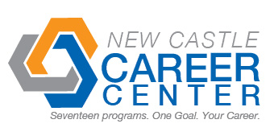
Student Profile
Name | Matthew Sabo
Address | 4039 N. Cozy Hollow Ln. New Castle, IN 47362
Cell Number | (765) 524-4870 |  | Email |  |  | matthewsabo21@gmail.com
Career Program | Pre-Engineering
Certifications | Autodesk Inventor Certified User ~ Anticipated
Dual Credits | 12-Ivy Tech Engineering
Attendance: Days Missed This Year | 1 | Reason for Absences |  | Sick
Graduation Date | 2014 | High School |  | Blue River Valley
Employment Interest | Engineering
Teacher Reference | Mr. Neal |  |  |  | Teacher Contact # |  | (765) 593-6680
Past Employers | Wendy’s
Able to Pass  Drug Test | Yes
Employer Notes about the Student

